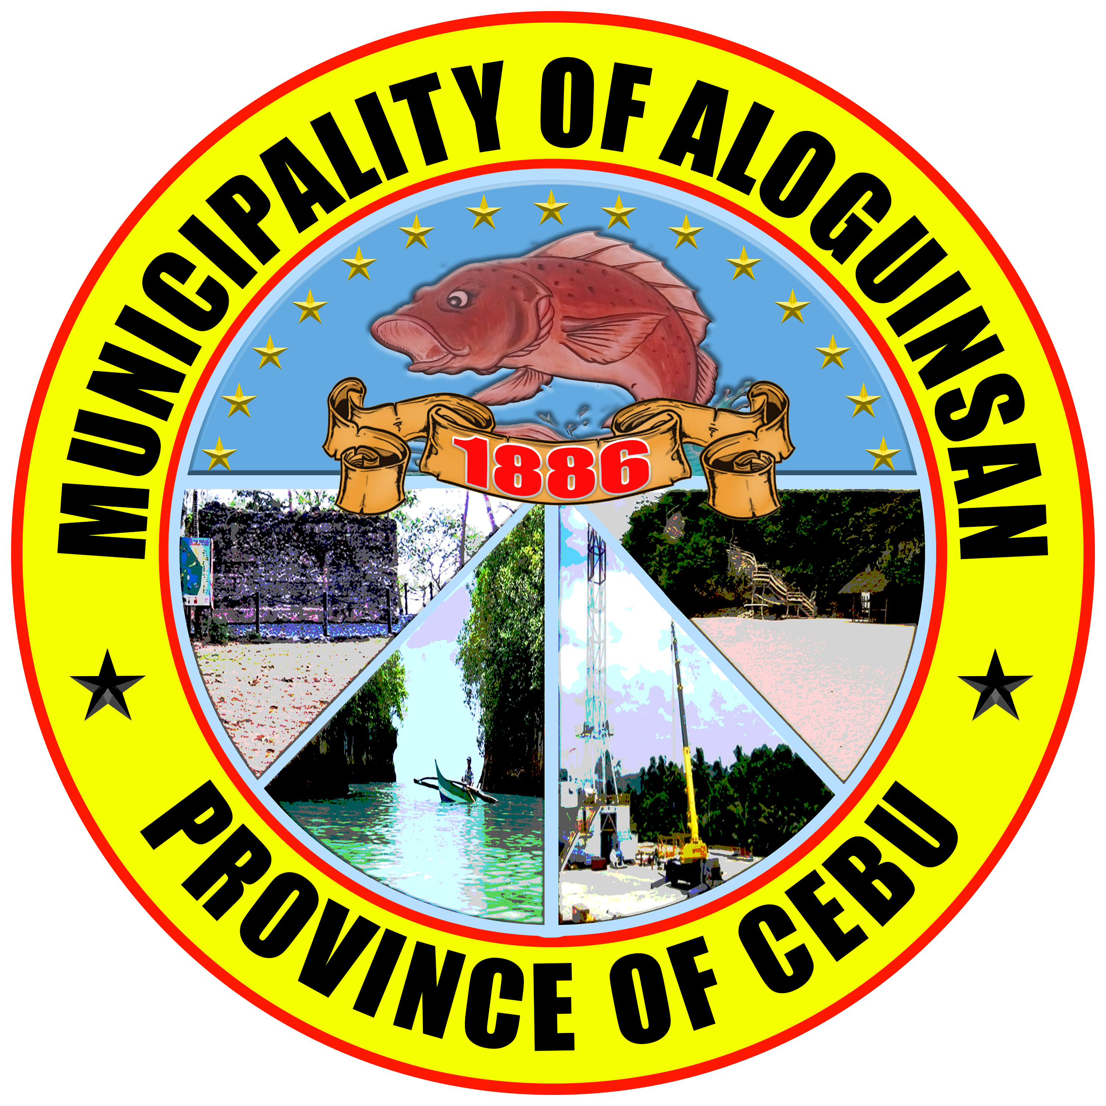Republic of the Philippines

Province of Cebu

Municipality of ALOGUINSAN

**TOURISM OFFICE**

**MARKET SCOPING**

1. **AGENCY INFORMATION**

|  |  |
| --- | --- |
| Name of Procuring Entity | Municipality of Aloguinsan |
| End-User/Implementing Unit | Tourism Office |
| Name & Designation of Representative | Myrna Tribunalo – Tourism Staff |

1. **PROJECT OVERVIEW**

|  |  |
| --- | --- |
| Project Name | PPMP 2026 (Tourism Office) |
| Estimated Budget | 130,000.00 |
| Period of Market Scoping  [From (mm/yyyy) To (mm/yyyy)] | 02/2026 – 09/2026 |
| Expected Date of Delivery *(mm/yyyy)* | 11/2026 |

# MARKET SCOPING ACTIVITY/IES CONDUCTED (*Check all that apply)*

This confirms that market scoping activities were conducted in accordance with Section 10 of Republic Act No. 12009 and its Implementing Rules and Regulations (IRR), and considered in the Project Procurement Management Plan, consistent with the Principle of Proportionality.

| **Check (✓)** | **Activity/ies Conducted** | **Documentation**  (as may be applicable) |
| --- | --- | --- |
| ☐ | Consultations with suppliers / contractors / consultants/ professional associations or industry groups | Highlights of consultations or meetings/ Proof of attendance/ Reports / Summaries/ Screenshots / Brochures / Publications/ Price quotations/ Canvass sheets/ Market Analysis Report or similar document/s |
| ☐ | Participation in summits, fora, or conferences | Highlights of consultations or meetings/ Proof of Attendance/ Reports |
| ☐🗸 | Review of technical, financial, or market/scientific reports | Reports / Summaries/ Screenshots / Brochures / Publications, Market Analysis Report or similar document/ Online Product Reviews |
| ☐ | Review of product or service brochures, marketing materials, industry journals and publications or related materials | Reports / Summaries/ Screenshots / Brochures / Publications/ Online Product Reviews |
| ☐🗸 | Price sourcing for quotations or cost estimates from suppliers, contractors, or consultants | Price quotations/ Canvass sheets/ Online Product Reviews |
| ☐ | Use of data from PhilGEPS or agency websites | Reports / Summaries/ Screenshots, Price quotations/ Canvass sheets/ PhilGEPS Postings/ Online Product Reviews |
| ☐ | Other analogous market scoping activity/ies undertaken: |  |

*Notes:*

1. *The market scoping activities shall be identified and undertaken at the option of the End-User or Implementing Unit based on its needs and objectives.*
2. *The list of supporting documents in the Documentation column is not exclusive and may include other documents that may be gathered by the End-User or Implementing Unit pertinent to the activity/ies conducted.*

# MARKET SCOPING RESULTS

Indicate recommendations in the column provided based on the results of the market scoping activities undertaken. These recommendations shall be considered in the development of a comprehensive and realistic PPMP, taking into account the parameters outlined under Section 10.4 of the IRR of RA 12009, as may be applicable.

| **Parameters** | **Considered?** *(Yes/No/ Not Applicable)* | **Recommendations**  **based on the Market Scoping**  (*Attach additional documents*  *if necessary)* |
| --- | --- | --- |
| 1. **Project Cost Estimate**   [Does the cost estimate align with current market prices?] |  |  |
| 1. **Project Design and Specification**   [Does available supplier/s meet technical and financial requirements?] |  |  |
| 1. **Technical Criteria**   [Does the market support the proposed technical requirements?] |  |  |
| 1. **Delivery Lead Time**   [Are the timelines for delivery feasible?] |  |  |
| 1. **Storage and Warehousing Requirements**   [Can the storage/ warehousing needs be met considering specific conditions like temperature, humidity, and handling?] |  |  |
| 1. **Identified Risk/s**   [Were there any market risks identified? (e.g., limited suppliers, price volatility)] |  |  |

|  |  |
| --- | --- |
| Prepared by:  *Myrna Tribunalo*  *Tourism Staff*  *August 14, 2025* | Approved by:  *Shane M. Navarro*  *Tourism Officer*  *August 14, 2025* |